Intersecting Planes

Definition
# Source: AI Source: Provided by: [Data Path: Persons Table -> ID Column: 1, Name_En Column: Motasem Essam] -> From: [ChatGPT] on [7/25/2026]
Intersecting planes are two distinct planes in three-dimensional space that share a common straight line. This line is called the line of intersection.
When two nonparallel planes intersect in Euclidean solid geometry, they meet along exactly one straight line that extends infinitely in both directions.
For example, two adjacent walls of a room meet along a vertical edge. If the walls are idealized as infinite planes, their common edge represents the line of intersection.
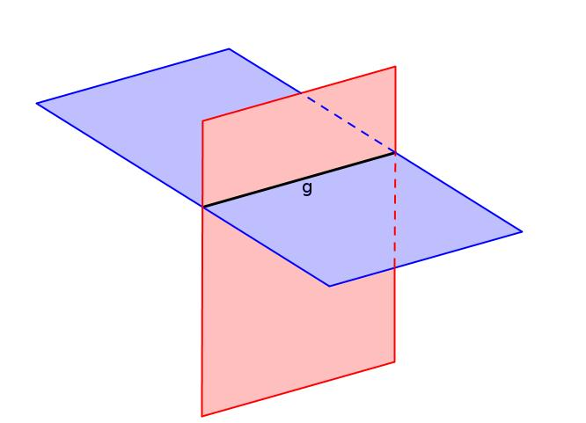
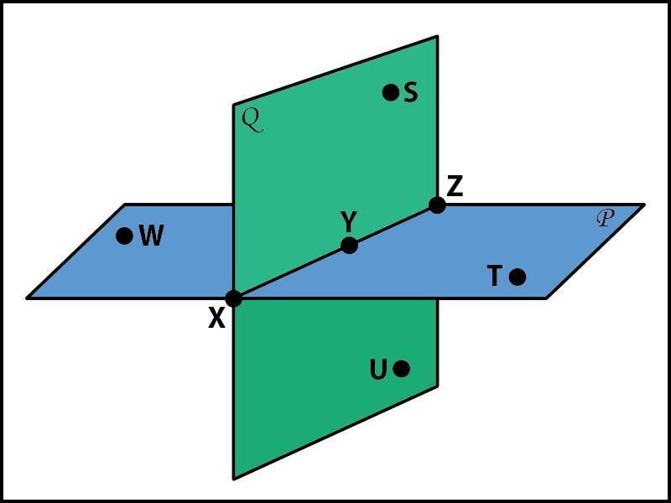
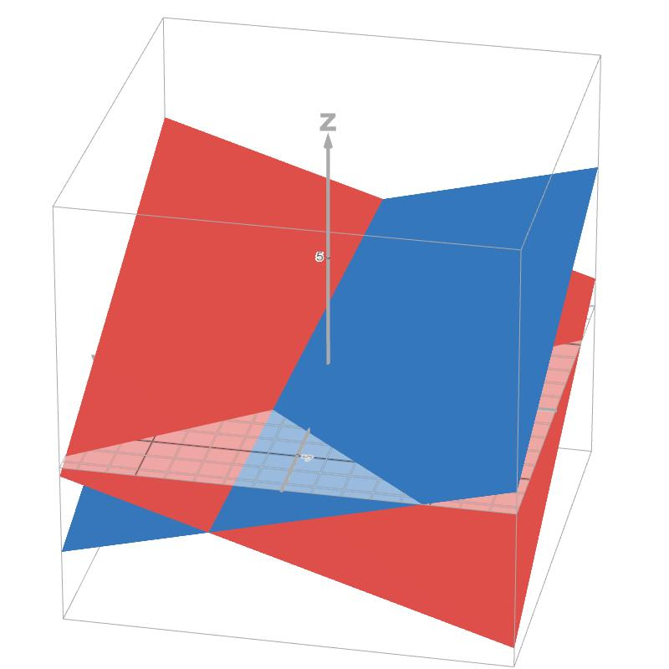

Simple Definition
# Source: AI Source: Provided by: [Data Path: Persons Table -> ID Column: 1, Name_En Column: Motasem Essam] -> From: [ChatGPT] on [7/25/2026]
Two planes are intersecting planes when they cross each other along a straight line.
Examples include:
- Two adjacent walls meeting at a corner.
- A wall and a floor meeting along an edge.
- Two flat surfaces crossing at an angle.
Unlike parallel planes, intersecting planes have points in common. Unlike coincident planes, they are not the same plane.

Key Characteristics
# Source: AI Source: Provided by: [Data Path: Persons Table -> ID Column: 1, Name_En Column: Motasem Essam] -> From: [ChatGPT] on [7/25/2026]
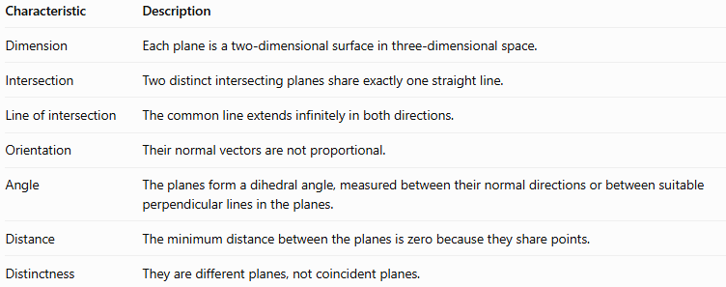
Characteristic | Description
Dimension | Each plane is a two-dimensional surface in three-dimensional space.
Intersection | Two distinct intersecting planes share exactly one straight line.
Line of intersection | The common line extends infinitely in both directions.
Orientation | Their normal vectors are not proportional.
Angle | The planes form a dihedral angle, measured between their normal directions or between suitable perpendicular lines in the planes.
Distance | The minimum distance between the planes is zero because they share points.
Distinctness | They are different planes, not coincident planes.

Geometric Representation
# Source: AI Source: Provided by: [Data Path: Persons Table -> ID Column: 1, Name_En Column: Motasem Essam] -> From: [ChatGPT] on [7/25/2026]
The diagram shows two planes, $P_{1}$ and $P_{2}$, intersecting along a common straight line $L$.
Two distinct planes share the straight line $L$.
The line $L$ belongs to both planes. Every point on this line lies on $P_{1}$ and $P_{2}$.

Mathematical Representation

General equations of two planes
# Source: AI Source: Provided by: [Data Path: Persons Table -> ID Column: 1, Name_En Column: Motasem Essam] -> From: [ChatGPT] on [7/25/2026]
Two planes in three-dimensional Cartesian coordinates can be represented by
$$P_{1}:A_{1}x+B_{1}y+C_{1}z+D_{1}=0$$
$$P_{2}:A_{2}x+B_{2}y+C_{2}z+D_{2}=0$$
Their normal vectors are
$$n_{1}=\left(A_{1},B_{1},C_{1}\right)$$
$$n_{2}=\left(A_{2},B_{2},C_{2}\right)$$
The planes intersect in a line if their normal vectors are not proportional.
Equivalently,
$$n_{1}×n_{2}≠0$$
The cross product gives a direction vector for the line of intersection.

Finding the line of intersection
# Source: AI Source: Provided by: [Data Path: Persons Table -> ID Column: 1, Name_En Column: Motasem Essam] -> From: [ChatGPT] on [7/25/2026]
To find the intersection line:
- Write both plane equations.
- Solve the two equations simultaneously.
- Express the solutions using one free parameter, when the planes are not parallel.
- Identify a point on the line and its direction vector.
The direction vector is perpendicular to both plane normals:
$$v=n_{1}×n_{2}$$
If $P_{0}=\left(x_{0},y_{0},z_{0}\right)$ is a point on the intersection line, its vector equation is
$$\boxed{r=r_{0}+tv}$$
where $t$ is any real number.

Angle between intersecting planes
# Source: AI Source: Provided by: [Data Path: Persons Table -> ID Column: 1, Name_En Column: Motasem Essam] -> From: [ChatGPT] on [7/25/2026]
The angle between two planes is commonly taken as the smaller angle between them, from $0^{∘}$ to ${90}^{∘}$.
Using the normal vectors, the angle $θ$ is
$$\boxed{θ=\cos^{-1}\left(\frac{\left|n_{1}⋅n_{2}\right|}{\left\|n_{1}\right\|\left\|n_{2}\right\|}\right)}$$
The absolute value selects the smaller angle between the planes.
- If $θ={90}^{∘}$, the planes are perpendicular.
- If $θ≠{90}^{∘}$, they intersect obliquely.
- If their normals are proportional, the planes are parallel or coincident rather than distinct intersecting planes.

Worked Examples
# Source: AI Source: Provided by: [Data Path: Persons Table -> ID Column: 1, Name_En Column: Motasem Essam] -> From: [ChatGPT] on [7/25/2026]
Example 1: Identifying intersecting planes
Determine the relationship between the planes
$$P_{1}:x+y+z=6$$
$$P_{2}:x-y+z=2$$
Step 1: Find the normal vectors.
$$n_{1}=\left(1,1,1\right)$$
$$n_{2}=\left(1,-1,1\right)$$
Step 2: Compare the normal vectors.
The vectors are not proportional. Therefore, the planes intersect in a straight line.
Step 3: Find the intersection line.
Subtract the second equation from the first:
$$2y=4⟹y=2$$
Substitute $y=2$ into the first equation:
$$x+z=4$$
Let $x=t$. Then $z=4-t$.
Thus, the intersection line is
$$\boxed{\left(x,y,z\right)=\left(t,2,4-t\right)}$$
or, in vector form,
$$\boxed{r=\left(0,2,4\right)+t\left(1,0,-1\right)}$$
The line passes through $\left(0,2,4\right)$ and has direction vector $\left(1,0,-1\right)$.
Example 2: Finding the angle between intersecting planes
Find the smaller angle between
$$P_{1}:x+y=0$$
$$P_{2}:x-y=0$$
Their normal vectors are
$$n_{1}=\left(1,1,0\right), n_{2}=\left(1,-1,0\right)$$
Calculate their dot product:
$$n_{1}⋅n_{2}=1\left(1\right)+1\left(-1\right)+0\left(0\right)=0$$
Therefore,
$$θ=\cos^{-1}\left(0\right)=\boxed{{90}^{∘}}$$
Conclusion: The planes are perpendicular intersecting planes. Their common line is the $z$-axis.
Example 3: Intersecting coordinate planes
Consider
$$P_{1}:z=0$$
$$P_{2}:y=0$$
The first plane is the $xy$-plane, and the second is the $xz$-plane.
Both equations hold when $y=0$ and $z=0$, while $x$ can be any real number.
Therefore, their intersection is
$$\boxed{\left(x,y,z\right)=\left(t,0,0\right)}$$
This is the $x$-axis.

Comparison with Related Concepts
# Source: AI Source: Provided by: [Data Path: Persons Table -> ID Column: 1, Name_En Column: Motasem Essam] -> From: [ChatGPT] on [7/25/2026]
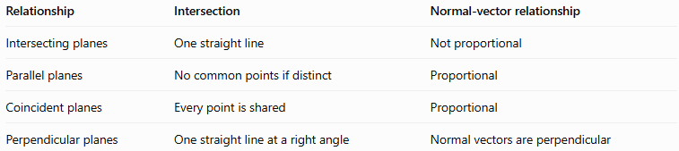
Relationship | Intersection | Normal-vector relationship
Intersecting planes | One straight line | Not proportional
Parallel planes | No common points if distinct | Proportional
Coincident planes | Every point is shared | Proportional
Perpendicular planes | One straight line at a right angle | Normal vectors are perpendicular
Important: Perpendicular planes are a special case of intersecting planes. All perpendicular planes intersect, but not all intersecting planes are perpendicular.

Applications
# Source: AI Source: Provided by: [Data Path: Persons Table -> ID Column: 1, Name_En Column: Motasem Essam] -> From: [ChatGPT] on [7/25/2026]
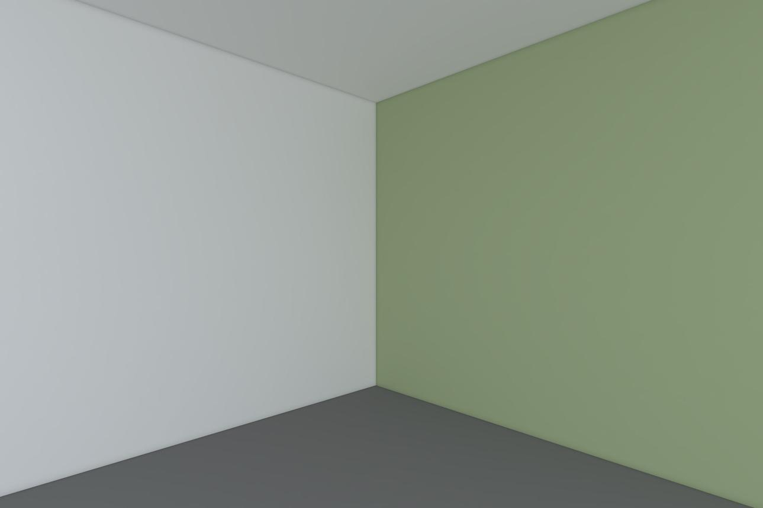
Architecture and construction
Adjacent walls intersect along an edge. Their angle determines whether the corner is square or oblique.
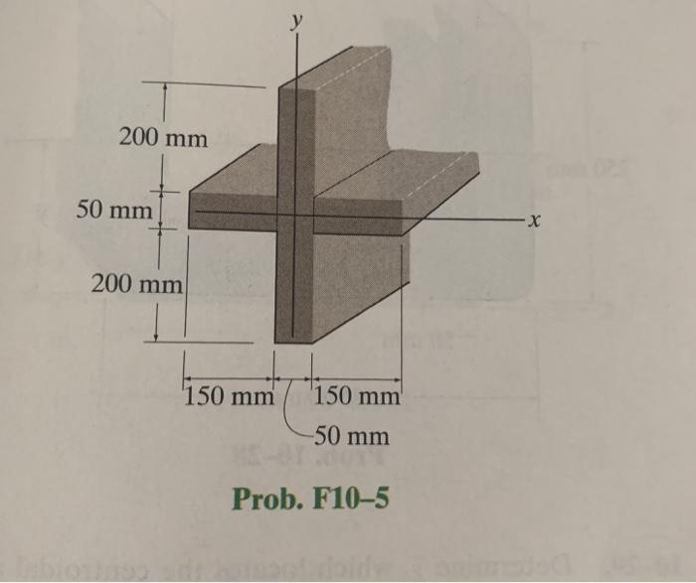
Mechanical engineering
Intersecting surfaces help describe joints, cutting planes, and the geometry of manufactured components.
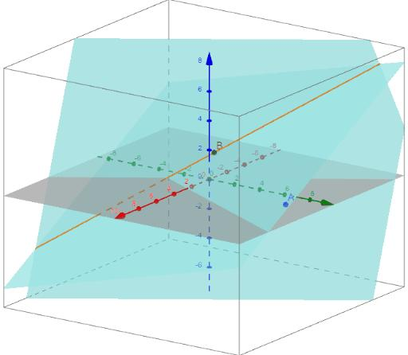
Computer graphics and CAD
Plane intersections are used in 3D modeling, surface clipping, geometric calculations, and spatial design.

Key Points
# Source: AI Source: Provided by: [Data Path: Persons Table -> ID Column: 1, Name_En Column: Motasem Essam] -> From: [ChatGPT] on [7/25/2026]
- Two distinct nonparallel planes intersect along exactly one straight line.
- Their normal vectors are not proportional.
- The cross product of their normal vectors gives the direction of the intersection line.
- The angle between planes can be calculated using their normal vectors.
- Perpendicular planes intersect at \(90^\circ\).
- The intersection line belongs to both planes.

Conclusion
# Source: AI Source: Provided by: [Data Path: Persons Table -> ID Column: 1, Name_En Column: Motasem Essam] -> From: [ChatGPT] on [7/25/2026]
Intersecting planes are two distinct planes that share a straight line in three-dimensional space. Their relationship can be analyzed using plane equations, normal vectors, simultaneous equations, and vector cross products. Understanding intersecting planes is essential for studying angles, lines, and spatial relationships in solid geometry.

